Industry Dashcam
Quick Start Guide

Legal Information
About this Document
- This Document includes instructions for using and managing the Product. Pictures, charts, images and all other information hereinafter are for description and explanation only.
- The information contained in the Document is subject to change, without notice, due to firmware updates or other reasons. Please find the latest version of the Document at the Hikvision website (https://www.hikvision.com). Unless otherwise agreed, Hangzhou Hikvision Digital Technology Co., Ltd. or its affiliates (hereinafter referred to as "Hikvision") makes no warranties, express or implied.
- Please use the Document with the guidance and assistance of professionals trained in supporting the Product.
About this Product
This product can only enjoy the after-sales service support in the country or region where the purchase is made.
Acknowledgment of Intellectual Property Rights
- Hikvision owns the copyrights and/or patents related to the technology embodied in the Products described in this Document, which may include licenses obtained from third parties.
- Any part of the Document, including text, pictures, graphics, etc., belongs to Hikvision. No part of this Document may be excerpted, copied, translated, or modified in whole or in part by any means without written permission.
-  and other Hikvision’s trademarks and logos are the properties of Hikvision in various jurisdictions.
- Other trademarks and logos mentioned are the properties of their respective owners.
LEGAL DISCLAIMER
- TO THE MAXIMUM EXTENT PERMITTED BY APPLICABLE LAW, THIS DOCUMENT AND THE PRODUCT DESCRIBED, WITH ITS HARDWARE, SOFTWARE AND FIRMWARE, ARE PROVIDED "AS IS" AND "WITH ALL FAULTS AND ERRORS". HIKVISION MAKES NO WARRANTIES, EXPRESS OR IMPLIED, INCLUDING WITHOUT LIMITATION, MERCHANTABILITY, SATISFACTORY QUALITY, OR FITNESS FOR A PARTICULAR PURPOSE. THE USE OF THE PRODUCT BY YOU IS AT YOUR OWN RISK. IN NO EVENT WILL HIKVISION BE LIABLE TO YOU FOR ANY SPECIAL, CONSEQUENTIAL, INCIDENTAL, OR INDIRECT DAMAGES, INCLUDING, AMONG OTHERS, DAMAGES FOR LOSS OF BUSINESS PROFITS, BUSINESS INTERRUPTION, OR LOSS OF DATA, CORRUPTION OF SYSTEMS, OR LOSS OF DOCUMENTATION, WHETHER BASED ON BREACH OF CONTRACT, TORT (INCLUDING NEGLIGENCE), PRODUCT LIABILITY, OR OTHERWISE, IN CONNECTION WITH THE USE OF THE PRODUCT, EVEN IF HIKVISION HAS BEEN ADVISED OF THE POSSIBILITY OF SUCH DAMAGES OR LOSS.
- YOU ACKNOWLEDGE THAT THE NATURE OF THE INTERNET PROVIDES FOR INHERENT SECURITY RISKS, AND HIKVISION SHALL NOT TAKE ANY RESPONSIBILITIES FOR ABNORMAL OPERATION, PRIVACY LEAKAGE OR OTHER DAMAGES RESULTING FROM CYBER-ATTACK, HACKER ATTACK, VIRUS INFECTION, OR OTHER INTERNET SECURITY RISKS; HOWEVER, HIKVISION WILL PROVIDE TIMELY TECHNICAL SUPPORT IF REQUIRED.
- YOU AGREE TO USE THIS PRODUCT IN COMPLIANCE WITH ALL APPLICABLE LAWS, AND YOU ARE SOLELY RESPONSIBLE FOR ENSURING THAT YOUR USE CONFORMS TO THE APPLICABLE LAW. ESPECIALLY, YOU ARE RESPONSIBLE, FOR USING THIS PRODUCT IN A MANNER THAT DOES NOT INFRINGE ON THE RIGHTS OF THIRD PARTIES, INCLUDING WITHOUT LIMITATION, RIGHTS OF PUBLICITY, INTELLECTUAL PROPERTY RIGHTS, OR DATA PROTECTION AND OTHER PRIVACY RIGHTS. YOU SHALL NOT USE THIS PRODUCT FOR ANY PROHIBITED END-USES, INCLUDING THE DEVELOPMENT OR PRODUCTION OF WEAPONS OF MASS DESTRUCTION, THE DEVELOPMENT OR PRODUCTION OF CHEMICAL OR BIOLOGICAL WEAPONS, ANY ACTIVITIES IN THE CONTEXT RELATED TO ANY NUCLEAR EXPLOSIVE OR UNSAFE NUCLEAR FUEL-CYCLE, OR IN SUPPORT OF HUMAN RIGHTS ABUSES.
- IN THE EVENT OF ANY CONFLICTS BETWEEN THIS DOCUMENT AND THE APPLICABLE LAW, THE LATTER PREVAILS.
© Hangzhou Hikvision Digital Technology Co., Ltd. All rights reserved.
Symbol Conventions
The symbols that may be found in this document are defined as follows.

Symbol | Description
Danger | Indicates a hazardous situation which, if not avoided, will or could result in death or serious injury.
Caution | Indicates a potentially hazardous situation which, if not avoided, could result in equipment damage, data loss, performance degradation, or unexpected results.
Note | Provides additional information to emphasize or supplement important points of the main text.

Safety Instructions
- Proper configuration of all passwords and other security settings is the responsibility of the installer and/or end-user.
- In the use of the product, you must be in strict compliance with the electrical safety regulations of the nation and region. Please refer to technical specifications for detailed information.
- Input voltage should meet limited power source or PS2 requirements according to the IEC60950-1 or IEC 62368-1 standard. Please refer to technical specifications for detailed information.
- Do not connect several devices to one power adapter as adapter overload may cause over-heating or a fire hazard.
- Please make sure that the plug is firmly connected to the power socket.
- If smoke, odor or noise rise from the device, turn off the power at once and unplug the power cable, and then please contact the service center.

CONTENTS
Chapter 1 Package Check 1
Chapter 2 Introduction 3
2.1 Product Introduction 3
2.2 Product Features 3
2.3 Overview of the Dashcam 4
2.4 Wiring 5
Chapter 3 Installation 7
3.1 Install the TF Card and SIM Card 7
3.2 Install the Camera 8
3.3 Install the Dashcam and Data Terminal 12
Chapter 4 Quick Configuration 13
4.1 Add Camera to App 13
4.2 Parameters Configurations 15
Chapter 5 FAQ 17
5.1 Dashcam Start Failure 17
5.2 Video Recording Failure 17
5.3 Position Failure 17
5.4 Blurred Video Image 17

Package Check
Please check the package of the camera for damages. After opening the package, please check the whether all the items are complete according to the table shown bellow. If all items are complete, then devices are ready for installation.
                - Packing List
No. | Picture | Name | Number
1 | 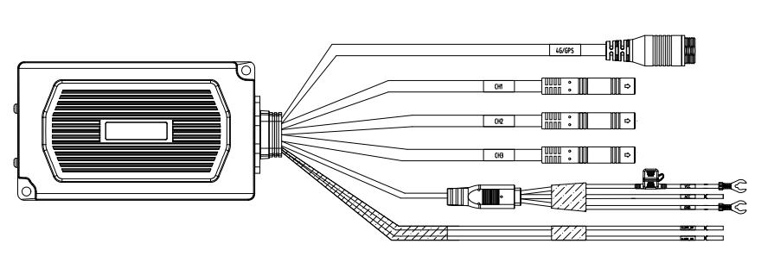 | Dashcam | 1
2 | 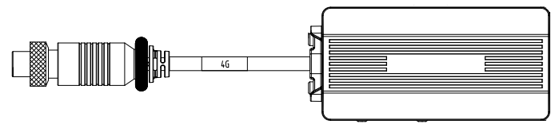 | Wireless Data Terminal | 1
3 | 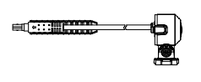 | Front Camera | 1
4 | 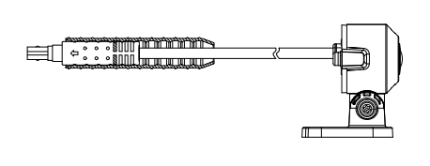 | Middle Camera | 1
5 |  | Rear Camera | 1
6 |  | Installation Screw Kit | 2
7 | 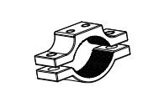 | Bracket | 1
8 | 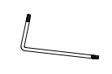 | L-type wrench | 1
9 |  | QUG | 1

Introduction

Product Introduction
This motorcycle dash cam is an intelligent video and audio monitoring product specifically designed for motorcycles, suitable for various riding scenarios. It utilizes advanced image capture technology and high-definition video recording to capture footage both in front of and behind the vehicle. With high-precision positioning technology, it offers excellent vehicle location services. The device employs intelligent AI algorithms to monitor lane departure, helmet detection, and dangerous riding behaviors in real-time. Combining rich functionality with outstanding performance, stability, compact design, low power consumption, and easy installation and maintenance, this dash cam delivers a comprehensive riding solution.

This product is subject to active development, which means that some functions may differ from what is presented in this manual. Please refer to the actual product for your reference.

Product Features
- Supports 3-channel 1080P camera input;
- Supports LDW, Helmet Detection, One-handed Riding Detection;
- Supports storage on one TF card, up to 1TB;
- Specifically designed for motorcycle waterproofing;
- Supports 2-channel I/O input;
- Supports HATC platform integration for remote operation and management;
- Supports cloud box expansion, providing 4G and GPS;
- Tamper-proof design, removing the device after installation will send an alarm to the platform.

Overview of the Dashcam
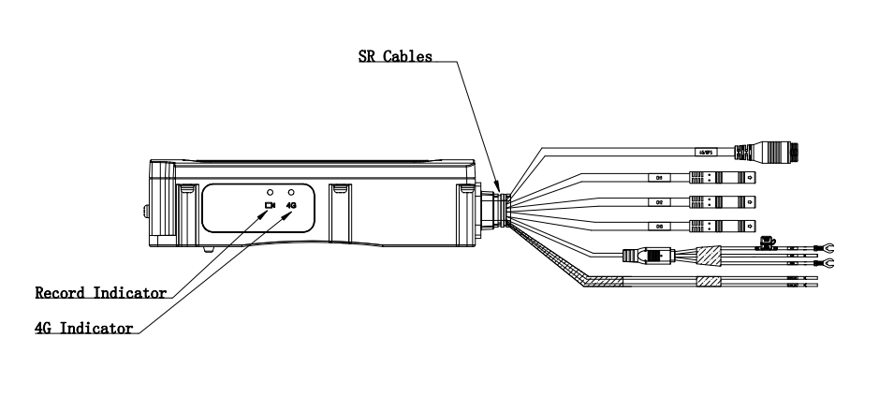
              - Front View
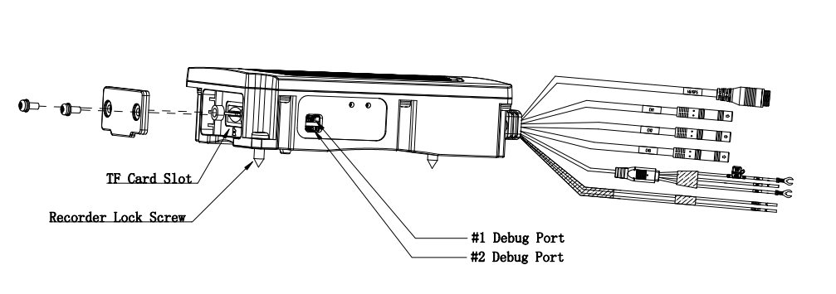
              - Front View
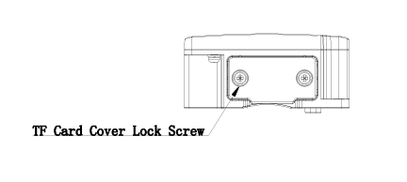
              - Side View
Refer to the following table for the meaning of indicators.
                - Indicator Status Description
Indicator | Status | Description
4G Indicator | Solid | 4G signal and the platform connection normal
4G Indicator | Flash | 4G signal is normal, but no platform connection
4G Indicator | Off | No 4G signal
Record Indicator | Solid | Extended camera is recording normally
Record Indicator | Flash | External Camera Recording Exception: Check TF Card
Record Indicator | Off | Extended camera stops / fails

Wiring
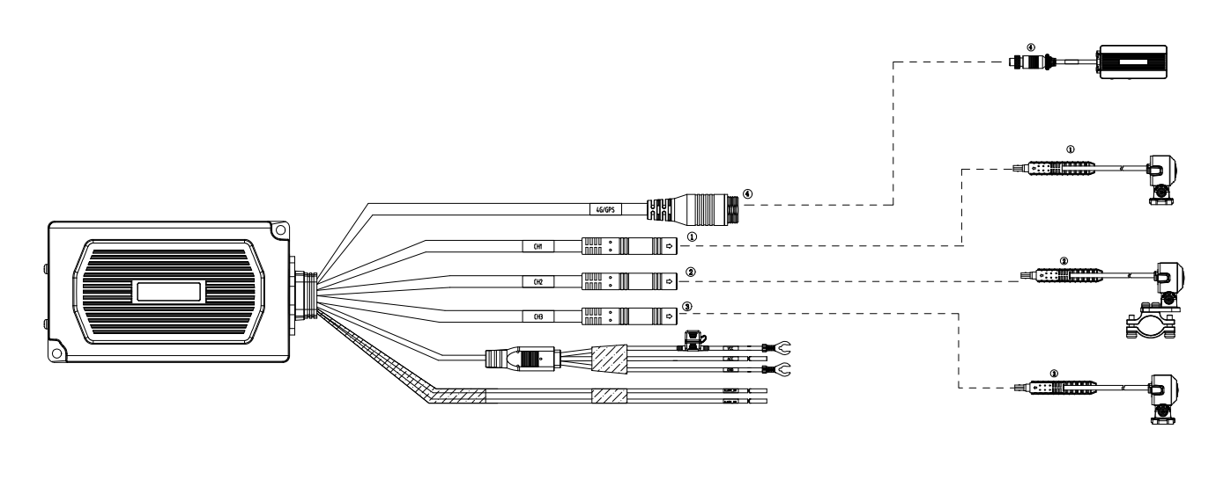
              - Wiring
                - Wiring Description
No | Interface Name | Interface Form | Interface Definition | Description
1 | 4G/GPS | 5-pin Aviation Plug | 1.P5V0_4G  2.USB_DM  3.USB_DP  4.GND | Connect the 5-pin male aviation plug connector to the female aviation plug connector of the 4G/GPS cloud box.
2 | CH1 | BMW 4-pin Male Plug | 1. 12V 2. GND 3. TVI1 4. NA | 4-pin male BMW connector to female BMW connector camera, or use a BMW connector to aviation connector adapter cable to connect to an aviation camera.
3 | CH2 | BMW 4-pin Male Plug | 1. 12V 2. GND 3. TVI2 4. NA | 4-pin male BMW connector to female BMW connector camera, or use a BMW connector to aviation connector adapter cable to connect to an aviation camera.
4 | CH3 | BMW 4-pin Male Plug | 1. 12V 2. GND 3. TVI3 4. NA | 4-pin male BMW connector to female BMW connector camera, or use a BMW connector to aviation connector adapter cable to connect to an aviation camera.
5 | VCC | Half Strip Wires | / | VCC Connected to Vehicle Power Positive Pole
6 | ACC | Half Strip Wires | / | ACC Connected To Vehicle ACC
7 | GND | Half Strip Wires | / | Connect GND to Vehicle Ground
8 | ALARM_IN1 | Half Strip Wires | / | Alarm input
9 | ALARM_IN2 | Half Strip Wires | / | Alarm input

Installation

Install the TF Card and SIM Card
The TF card is to for the storage of recordings and snapshots. The SIM card is for connecting to 3G/4G network. The installation method of both is the same.
The dashcam records videos in a loop. When the TF card storage is used up, then later recordings will cover earlier recordings. Please backup the recordings after an accident or other important events.

- You need to format the TF card when using the TF card for the first time. To format the TF card, you need to insert the TF card into the dashcam and then choose the TF card formation option on the dashcam app. Formation with a computer will not work.
          - Loose the screw of dashcam and open the cover from the bump of the cover.
          - Push the TF card into the slot until you hear a click sound.
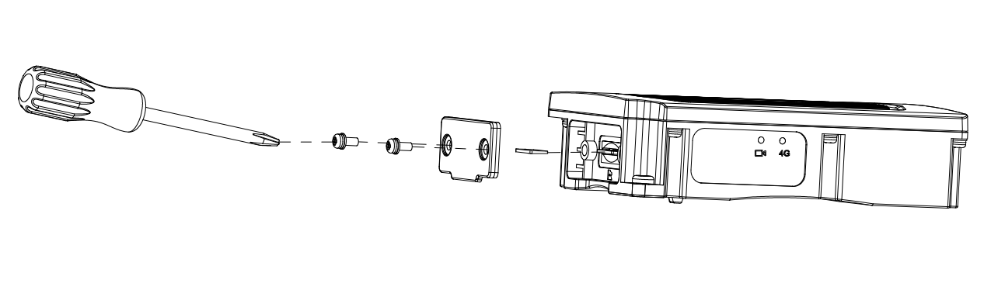
              - Insert TF Cards
          - Put the lid back and use a cross screwdriver to tighten the screws in the screw holes.
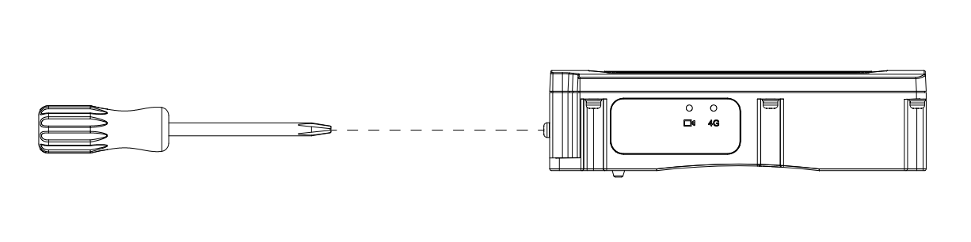
              - Lock Cover
          - Loose the screw of wireless data terminal and open the cover from the bump of the cover.
          - Push the SIM card into the slot until you hear a click sound.
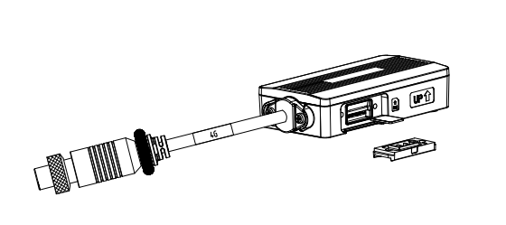
              - Insert SIM Cards
          - Put the lid back and use a cross screwdriver to tighten the screws in the screw holes.
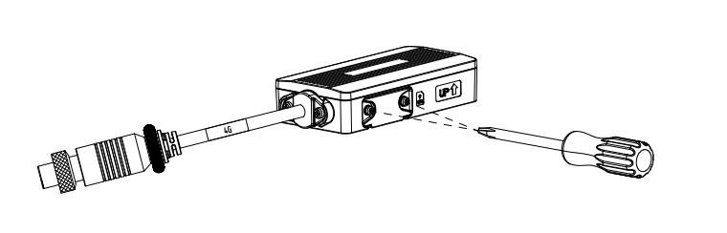

              - Lock Cover

The recording will start once the TF card is installed. Contact the sales for specialized app to set up recording parameters and management.

Install the Camera
The cameras are respectively installed at the front, middle, and rear positions of the motorcycle (The vehicle's bumper must maintain a certain distance from the front-view camera, and it must not touch the camera during riding).
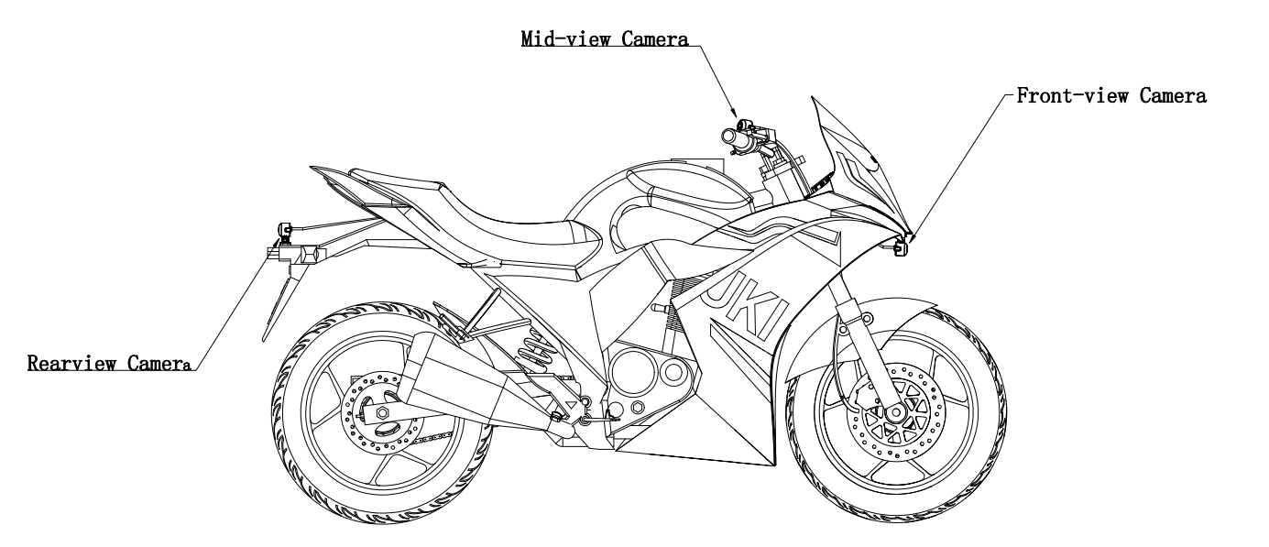


Please check if the device and all parts are intact in the package before installation.
          - Preparation for Front and Rear Camera Installation: Remove the device, use a T20 Torx wrench to loosen the three angle adjustment set screws, allowing the camera to rotate freely around the rotation shaft. The specific operation is shown in Figure 3-5 below.
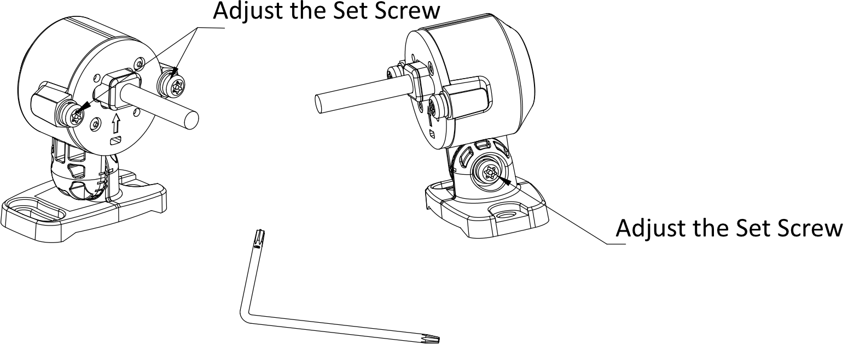
              - Adjust the Bracket
          - Install the front and rear view camera on a relatively flat surface of the vehicle body. Adjust the camera angle and base fixation position according to the image in the picture, and then rotate the bracket shaft to lock the installation screw. Refer to Figure 3-6. Make sure that you can operate the adjusting screw conveniently.
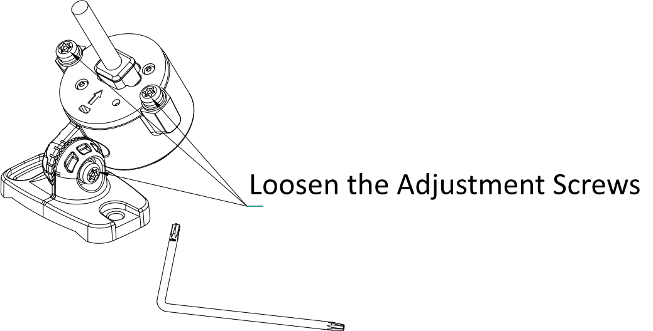
              - Adjust Angle
          - Select appropriate front and rear camera installation locations on the vehicle body: Secure the device base to the body with installation screws, as shown in Figure 3-7.
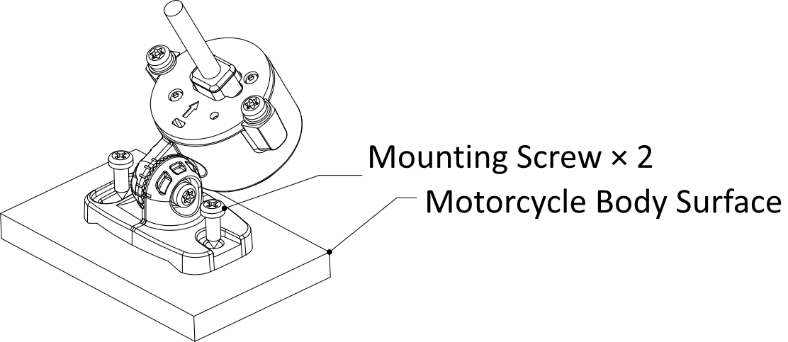
              - Vehicle Body Fixation
          - After installing the front and rear cameras, adjust the camera orientation: rotate the adjustment bracket shaft and rotate the adjustment camera orientation, lock the adjustment screw, and fix the adjustment angle, as shown in Figure 3-8.
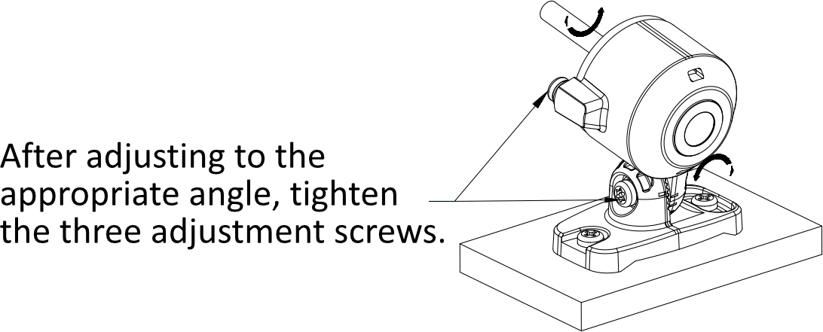
              - Camera Adjustment
          - Preparation for Camera Installation: Remove the Devices and mounting accessories. Use a T20 Torx wrench with a pin to loosen the three angle adjustment tighten screws, allowing the camera to rotate freely around the rotation shaft, as shown in Figure 3-9.
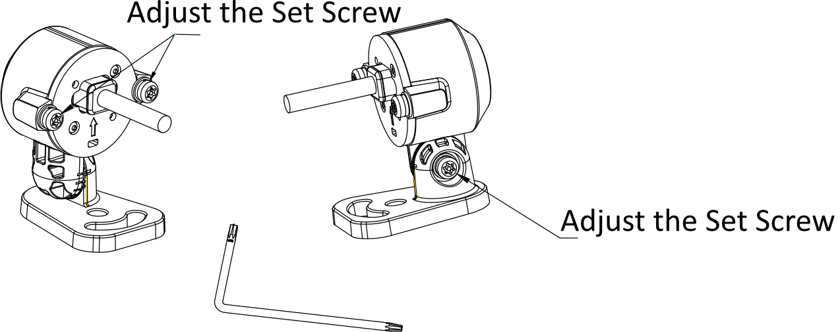
              - Adjust the Bracket
          - The central view camera is installed on the handlebar linkage, suitable for linkage diameters ranging from 20mm to 30mm. Adjust the camera angle and the installation position of the clamp according to the output image, and install the clamp bracket, as shown in Figure 3-10.
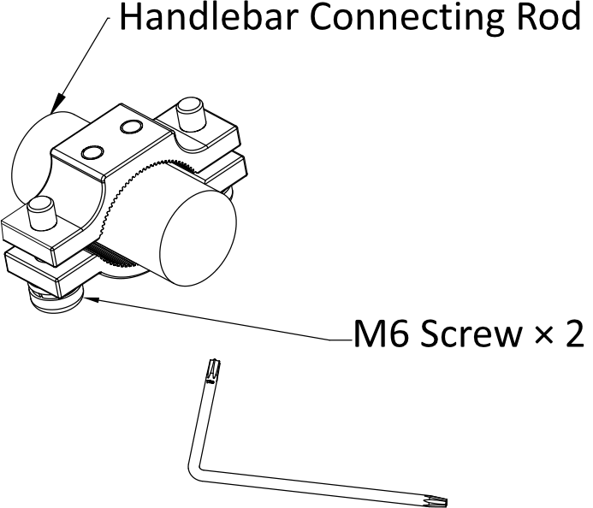
              - Clamp Mount Fixed
          - Install the camera on the vehicle body as shown in Figure 3-11. Rotate the bracket shaft to lock the installation screws, and fix the device base to the vehicle body.

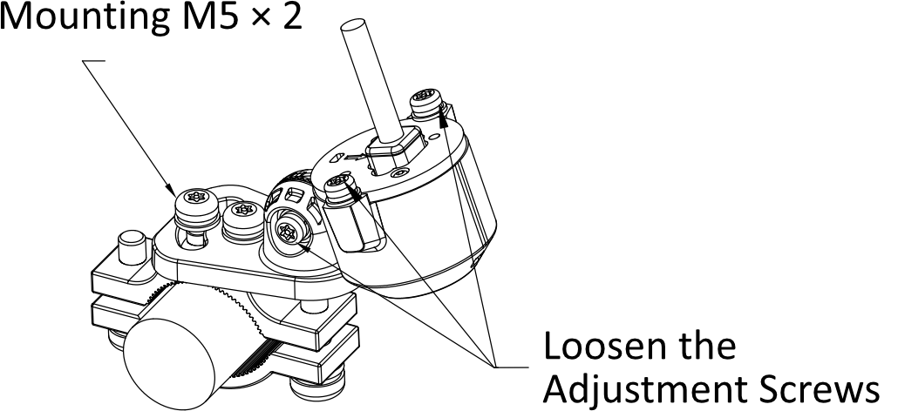
              - Camera Mounting
          - Central camera installation adjustment: rotate the adjustment bracket shaft and rotate the camera orientation, lock the adjustment screw, and fix the adjustment angle, as shown in Figure 3-12.
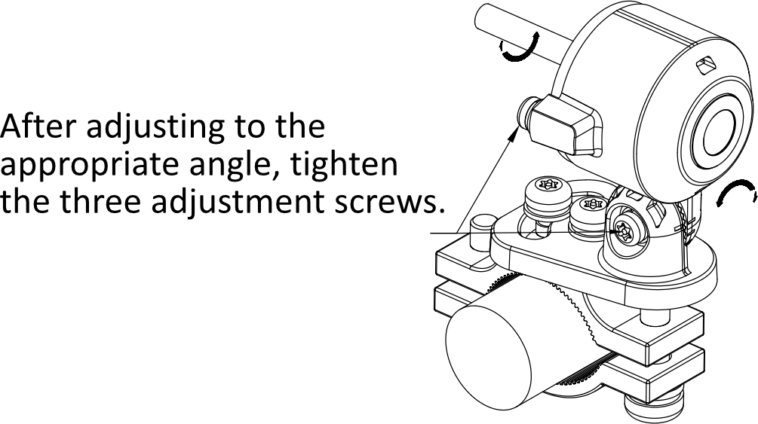
              - Camera Adjustment

Install the Dashcam and Data Terminal
Install the dashcam under the motorcycle seat, on a flat surface away from the engine exhaust outlet. Refer to the picture for details.
Mount the data terminal on a flat area of the motorcycle's front and secure it with adhesive backing.
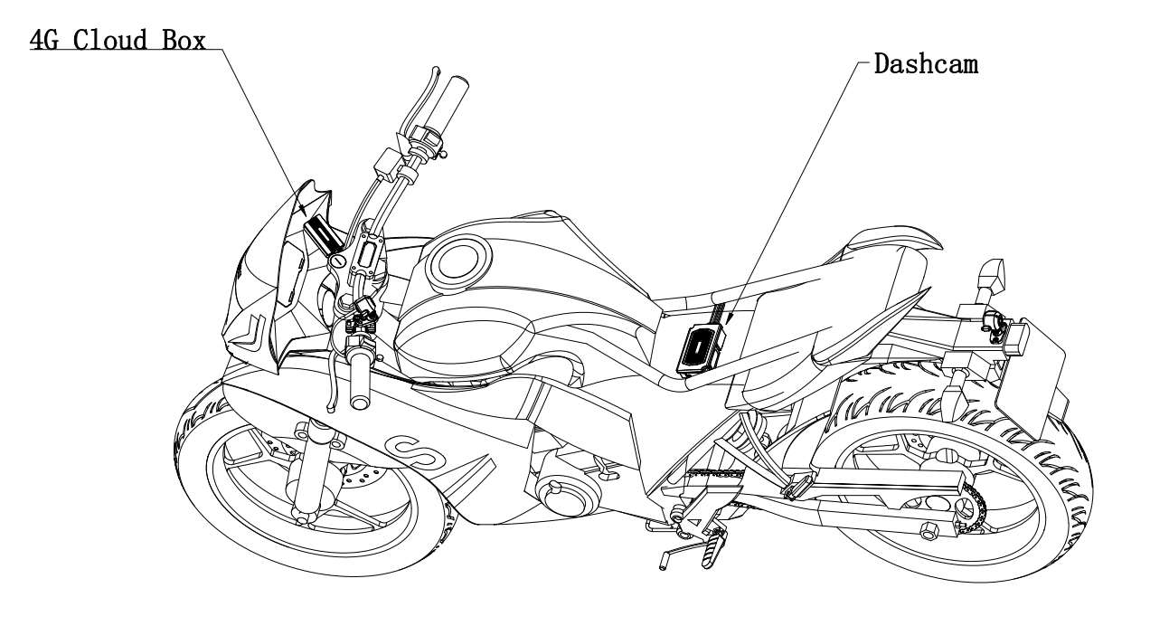
              - Installation Position
          - Connect the power cables: find the vehicle fuse. ACC to the vehicle ACC, VCC to the positive of the vehicle power, GND to the ground.
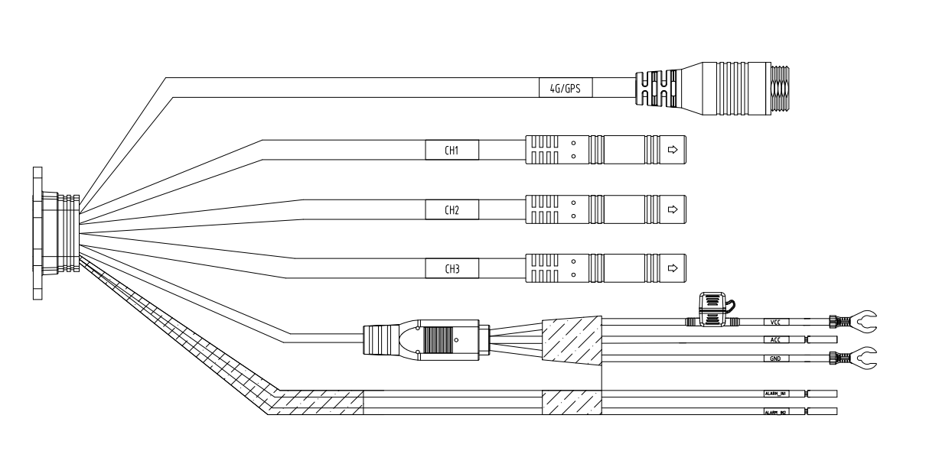
              - Connect the Power Cables
          - Connect the camera and cloud box harness to the recorder harness.
          - Install the camera into the APP according to the steps in Chapter 4.1, and adjust the corresponding camera angle to an appropriate angle (for the front and rear cameras, ensure that the image is not tilted, the vertical-to-horizontal aspect ratio of the image is 1:1, and there is no obstruction; for the center camera, ensure that the driver is within the frame and there are no obstructions).
          - Secure the main unit with screws and organize the corresponding wiring harness.

Quick Configuration

Add Camera to App
This dashcam requires HikDashcam App for taking snapshots, recording videos and configuration.
          - Scan the QR code bellow and download the Dashcam App.
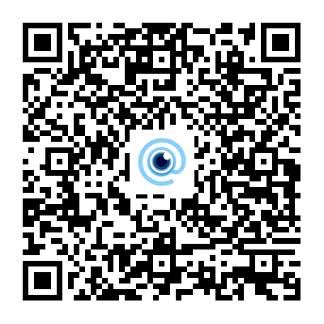
              - QR Code
          - Power on the Dashcam will enable its Wi-Fi (valid for 5 minutes).
          - Open the HikDashcam App and tap “Add Device”. The phone will go to the Wi-Fi setting page.
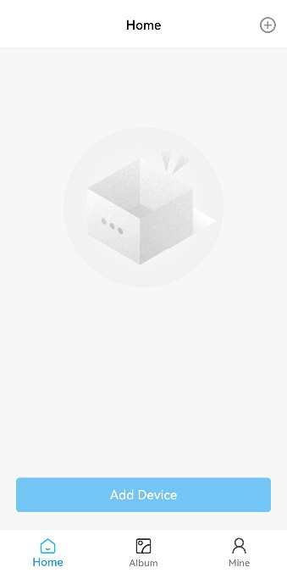
              - Dashcam Home Page
          - Connect to the Wi-Fi hotspot named “DASHCAM-G40S2-XXXX.” The string XXXX means the last four characters of the verification code on the dashcam. The default password is Dash12345.

- You should change the password for activation.
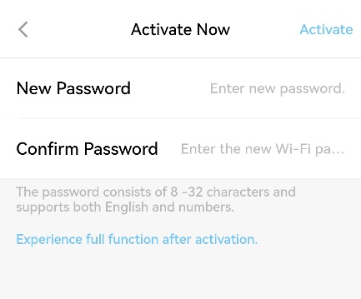
              - Activation
          - After activation, the device will added to the home page.
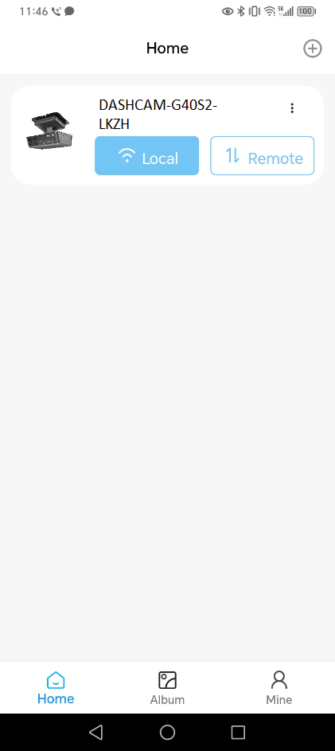
              - Added Device
          - Tap “Local” and go to Wi-Fi Settings page of the phone to join the device hotspot by new password.
          - Go back to the home page and do other operations.

Parameters Configurations
You can set the basic parameters and go to use the camera quickly.
          - Tap Settings to go to Smart Settings - ADAS (Advanced Driver Assistance System) Settings, and enable ADAS Settings.
          - On the ADAS Settings page, you can set the camera parameters.
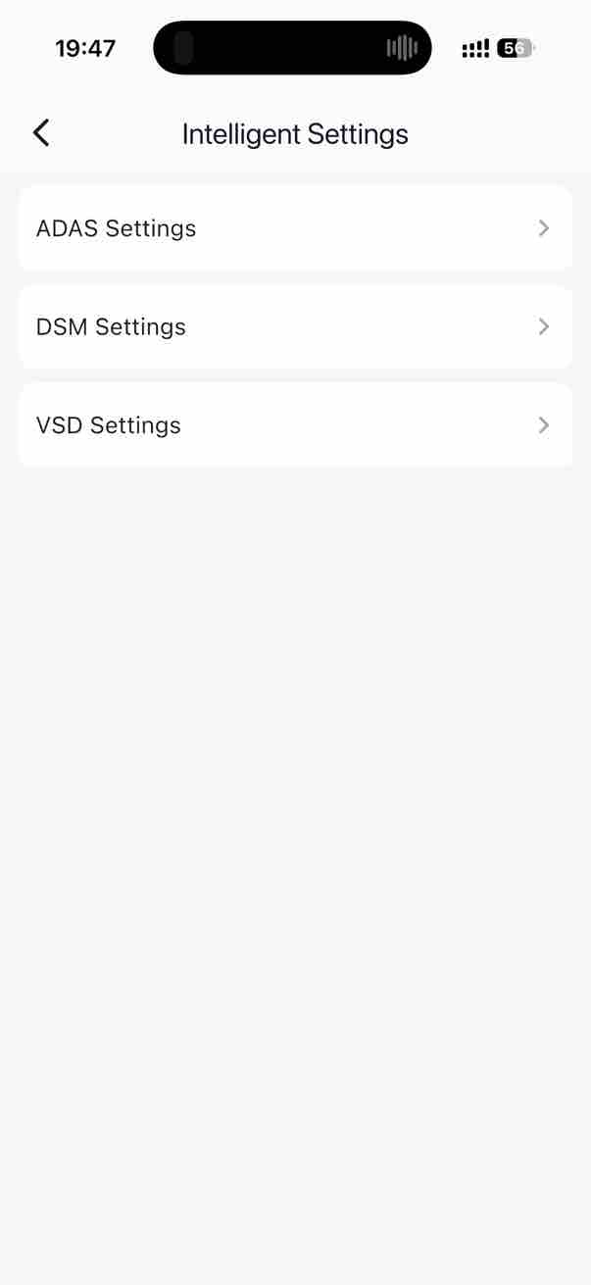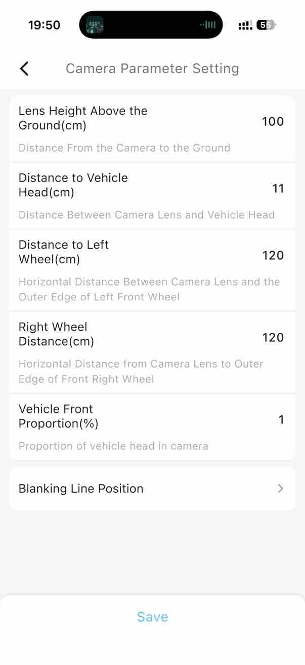
              - Camera Settings

FAQ

Dashcam Start Failure
• Check whether the power supply is consistent with the required parameters of the dashcam.
• Check that the power cord is properly connected.
• Check that the vehicle power supply is normal.

Video Recording Failure
• Please confirm that the vehicle dashcam has inserted a TF card.
• Please confirm if the TF card is damaged, and if it is damaged, replace the TF card.
• Please try formatting the TF card.

Position Failure
• Please check whether there is any obstruction around the vehicle, drive the vehicle to an open road, the GNSS indicator is always on to indicate that the equipment is operating normally.
• Do not fix the dashcam on the special car film, some car film will affect the positioning signal, you need to move the dashcam to a place without the car film covering.

Blurred Video Image
• Please check that the lens protector has been removed.
• Whether the lens is dirty.

UD43041B

